**ASSIGNMENT- 4**

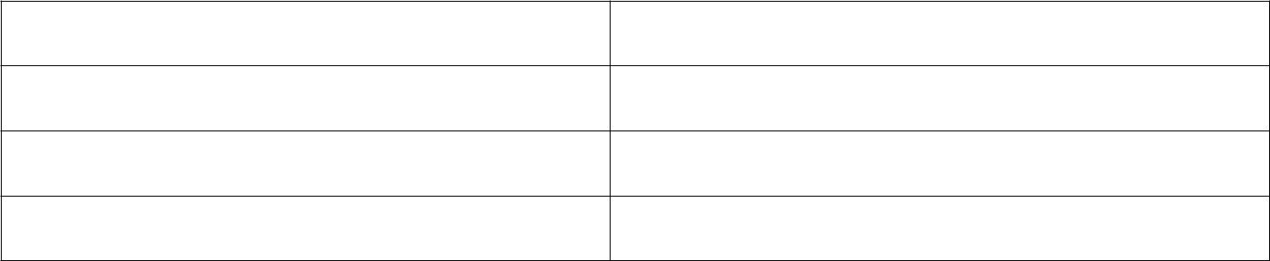

**Assignment Date**

**24**

**October 2022**

**Student Name**

**S.jayasri**

**Student Roll Number**

**210219106018**

**Maximum Mark**

**2**

**Marks**

**Question:**

Write code and connections in wokwi for ultrasonic. And for sending alert

**Program:**



#define ECHO_PIN 2

#define TRIG_PIN 3

void setup() {

**Serial**

.begin(9600);

pinMode(TRIG_PIN, OUTPUT);

pinMode(ECHO_PIN, INPUT);

}

float readDistanceCM() {

digitalWrite(TRIG_PIN, LOW);

delayMicroseconds(2);

digitalWrite(TRIG_PIN, HIGH);

delayMicroseconds(10);

digitalWrite(TRIG_PIN, LOW);

int duration = pulseIn(ECHO_PIN, HIGH);

return duration * 0.034 / 2;

}

void loop() {

float distance = readDistanceCM();

if(distance <= 100)

{

**Serial**

.println("person detected ");

}

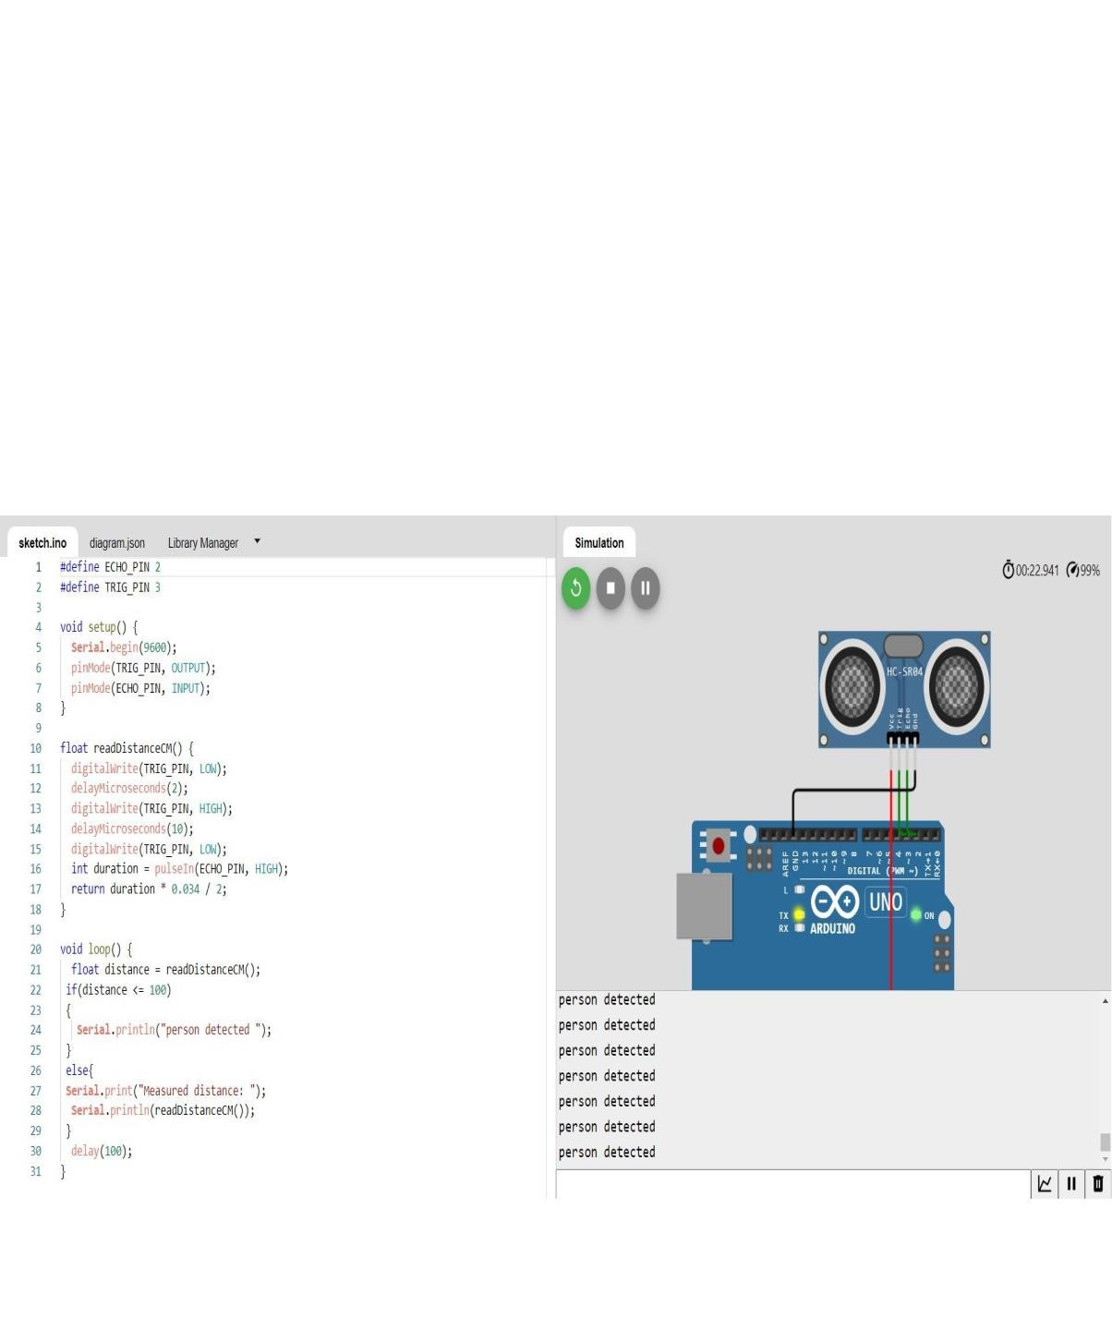

else{

**Serial**

.print("Measured distance: ");

**Serial**

.println(readDistanceCM());

}

delay(100);

}

**Wokwi Link:**<https://wokwi.com/projects/346965903633547858>

**IBM Cloud**

